**High Level Requirements**

**Boutique Recruitment**

**JC Consulting**

|  |  |
| --- | --- |
| Industry Partner | JC Consulting |
| Primary Instructor | Anjana Shah |
| Team Member | Abdallahman Habyarimana – 101087205 |
| Team Member | Anushka Aggarwal – 101195651 |
| Team Member | Karanjot Singh- 101195883 |
| Team Member | Renata Moura - 101096098 |
| Team Member |  |

Document Revision History

|  |  |
| --- | --- |
| Revision # | Date |
| Revision 1 | 10/11/2018 |

**Project Identification**

|  |  |
| --- | --- |
| **Project:** | JC Consulting |
| **Prepared By:** | Anushka Aggarwal |
| **Document Version:** | 0.2 |
| **Published Date:** | 10 October, 2018 |

**Contributors**

The following individuals contributed to this document.

| **Name** | **Title** |
| --- | --- |
| Renata Moura | *Project Leader* |
| Anushka Aggarwal | *Team Member* |
| Abdallahman Habyarimana | *Team Member* |
| Karanjot Singh | *Team Member* |

**Distribution**

This document is distributed to all the following people.

| **Name** | **Title** |
| --- | --- |
| Tyler Krimmel | Sponsor |
| Anjana Shan | Capstone Teacher |

**Referenced Documents**

This document refers to the following materials

|  |  |  |  |  |
| --- | --- | --- | --- | --- |
| **Version number** | **Title** | **Author** | **Date** | **Source / Location** |
| 0.1 | Project Vision | Renata Moura | 10 Oct, 2018 |  |
| 0.1 | Personas | Abdallahman Habyarimana /  Karanjot Singh | 10 Oct, 2018 |  |
| 0.1 | User Stories | Abdallahman Habyarimana /  Karanjot Singh | 10 Oct, 2018 |  |

**Revision History**

|  |  |  |  |
| --- | --- | --- | --- |
| **Version Number** | **Revision Date** | **Summary of Changes** | **Modified by** |
| 0.2 | *10/11/2018* | Words corrections and team members names | Renata Moura |
|  |  |  |  |
|  |  |  |  |

[Note: It is recommended that drafts be numbered 0.1 to 0.9, and that the first approved version be numbered 1.0. Thereafter, new version numbers will depend upon changes: 1.01, 1.1, etc for minor updates, 2.0, 3.0 etc for major changes.]

TABLE OF CONTENTS

1. Business Context Diagram 4

2. REquirements Scope Statements 5

3. High Level Business Requirements (HLR) Traceability 5

4. High Level Business Requirements Sign-Off 5

1. Business Context Diagram

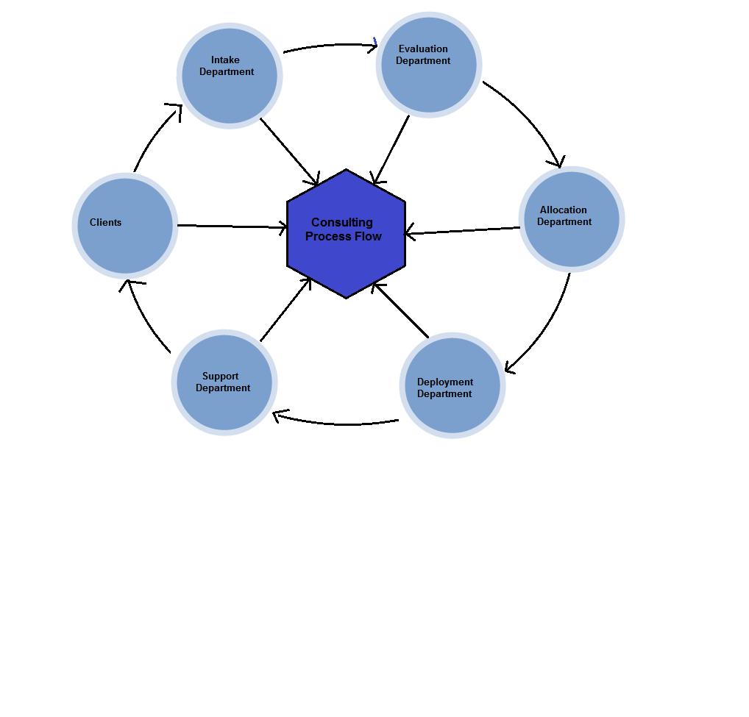

1

2

7

7

7

7

7

7

6

5

4

3





1

|  |  |
| --- | --- |
| **Requirement Scope Area** | **Description** |
| Clients’ side Registration and database | This project will cover the clients’ login and registration, creating a flow based candidate-client matching |

|  |  |
| --- | --- |
| **External Entity** | **Description** |
| Clients | The companies who are looking for potential employees to hire |
| Intake Department | It is going to input the clients’ information and requirements |
| Evaluation Department | They are responsible for evaluating the clients’ requirements against available candidates (Out of Scope) |
| Allocation Department | They are responsible for allocating the suitable candidates to the jobs (Out of Scope) |
| Deployment Department | They will see to the hiring process, the actual filling up of job positions (Out of Scope) |
| Support | They are responsible for maintaining the whole process, updating it and making sure any problems are quickly fixed so the whole system does not go down |

| **Information Flows** | **Description** |
| --- | --- |
| 1 | Clients’ requirements |
| 2 | Job positions available |
| 3 | Evaluated jobs against available candidates |
| 4 | Eligible candidates’ information |
| 5 | Hired candidates’ and filled positions’ information |
| 6 | Encouragement for further prospects |
| 7 | Included in the flow of the process |

1. Requirements Scope Statements

|  |  |  |
| --- | --- | --- |
| **HLR#** | **Description** | **Priority**  **(H, M, L)** |
|  | A flow-based registration process for clients searching for candidates | H |
| HLR02 | Creating user friendly login and registration interface for clients to sign up for our services and post their requirements | H |
| HLR03 | Creating a login and interface for the evaluators and administrator | H |
| HLR04 | Creating a database which would hold all available jobs and companies’ requirements | H |
| HLR05 | Matching clients’ requirements to candidates’ qualifications | L |
| HLR06 | Helping the clients save resources in time and money by searching potential candidates | M |

1. High Level Business Requirements (HLR) Traceability

A flow-based registration process for clients searching for candidates

A login and interface for the clients

Database which would hold all available jobs and companies’ requirement

A login and interface for the evaluators

A login and interface for the administrator

1. High Level Business Requirements Sign-Off

The undersigned acknowledge their agreement with the contents of Version <0.1> of the High-Level Requirements document for JC Consulting.

Following approval of this document, requirements changes will be governed by the project’s change management process, including impact analysis and appropriate reviews and approvals, under the general control of the Project Plan and according to company policy. Approved Change Request Documents, if present, will be attached to this Requirements Document as updates.

|  |  |  |
| --- | --- | --- |
| **Name** | **Project Role and**  **Functional Area** | **Date Signed** |
| Anushka Aggarwal | Team Member | 10 Oct,2018 |
| Renata Moura | Project Leader | 10 Oct,2018 |
| Karanjot Signh | Team Member | 10 Oct,2018 |
| Abdallahman Habyarimana | Team Member | 10 Oct,2018 |
| Tyler Kimmer | Sponsor |  |

* Note: physical signatures are not required. Email approvals are acceptable and should be appended to project documents.